**Project Name : Smart Glove**

**Introduction**

In a world dominated by visual cues, navigation and environmental awareness for the visually impaired can be challenging. Our project presents a groundbreaking solution- Echolocation Glove. The Echolocation Glove integrates an Arduino Uno microcontroller, ultrasonic sensor, battery, buzzer, and vibrator. The ultrasonic sensor emits sound waves, which bounce off obstacles and return to the glove. The Arduino Uno processes this data, providing real-time feedback to the user. When an object is detected, the glove triggers the buzzer and vibrator, providing tactile and auditory cues to help the user navigate safely.

**Components Required**

* Arduino IDE software
* Arduino Uno
* Glove
* Ultrasonic sensor
* Bread Board
* Buzzer
* Vibrating Motor
* Led (for indication)
* Resistor
* Connecting wires
* Battery (for external power supply)
* Switch (if external power supply is given)

**Circuit Diagram**

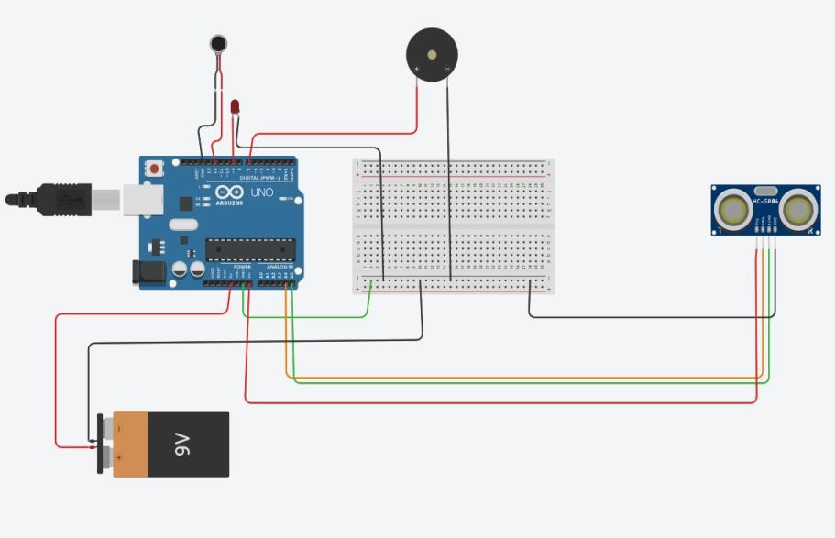

**Program**

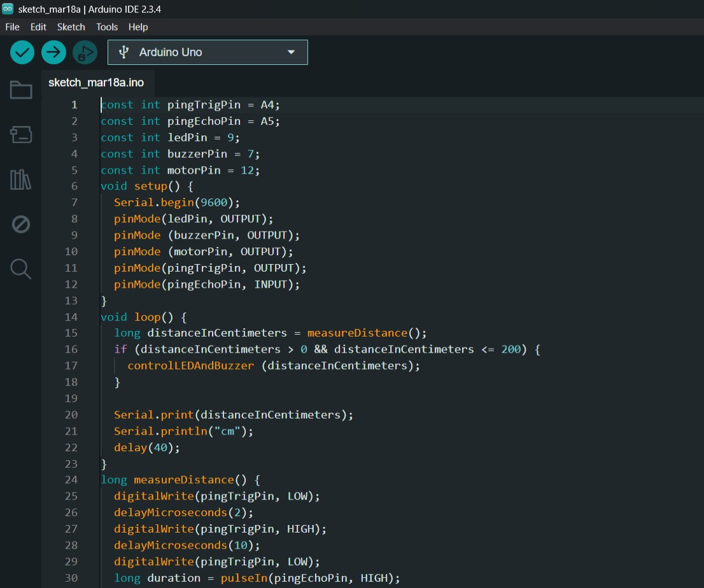

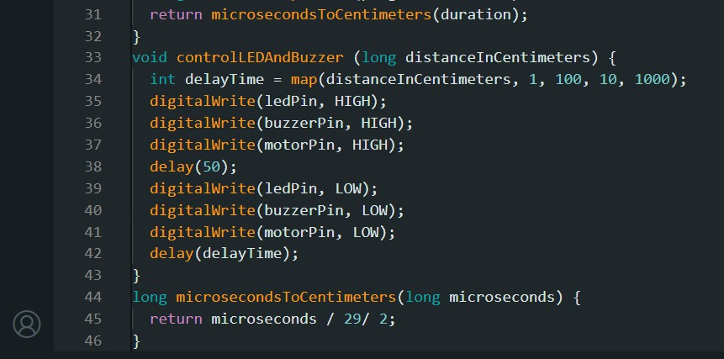

**Pictures**

